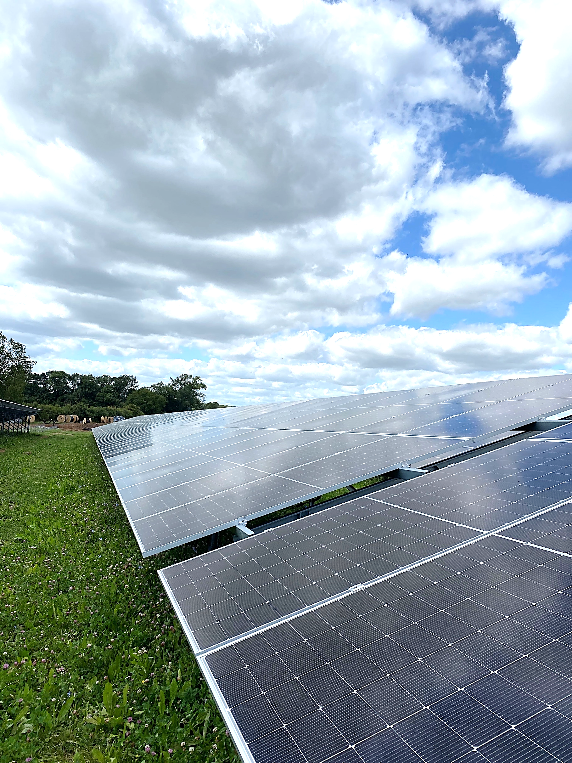


Hessay Solar Farm

Decommissioning Statement
Contents
1. Introduction 3
2. Parties involved 3
3. Public Highway condition 3
3.1 Highway condition survey 3
3.2 Compound management 3
3.3 Wheel washing facility 4
3.4 Decommissioning Works Phasing 4
4. Storage 4
5. Safety and Security 4
6. Decommissioning activities 5

- Introduction
This Decommissioning Method Statement has been prepared to outline the decommissioning process for Hessay Solar Farm. At the end of its operational lifespan the site will undergo the decommissioning process. This will aim to return the site area to its original condition prior to construction. Site materials will be appropriately disposed of according to the legislation in-place at the time of decommissioning any site materials that can be repurposed or sold as second hand will be highlighted. A qualified Ecological Clerk of works will be appointed to advise and oversee decommissioning phasing, with regard to protecting the site ecology and environment through the process. All relevant British Standards and Industry Codes will be followed such as BS3882 Specification for topsoil and BS 7370: Grounds Maintenance: All decommissioning works will be carried out by specialist decommissioning contractors, who will be governed by recycling and disposal regulations in force at the time.

- Parties involved
The Asset owner is Northern Power Grid.
Client, Hessay Solar Limited.
Principal Contractor is Ethical Power.
Contractors for the decommissioning work will be selected closer to the end of the Solar Installation’s operational life.

- Public Highway condition

3.1 Highway condition survey
On completion of the decommissioning works a road survey will be completed, and any remediation works will be identified. All decommissioning traffic will be required to enter and leave Site via the main access off Tinker Lane. An updated TMP will be submitted to York City Council Planning, and decommissioning contractors nearer the time. The access route will be made good from any damage caused during the decommissioning works.

3.2 Compound management
Prior to decommissioning a site traffic management plan will be created to assess traffic requirements and restrictions.

To avoid muddying the roadways, the compound will be managed to keep vehicles that will be exiting the site separate from muddier areas used by on-site vehicles.

No vehicle parking, loading, or unloading will take place on site internal roadways these operations will be constrained to solar farm site designated roadways and compound.

3.3 Wheel washing facility
When necessary, vehicle wheels will be manually cleaned prior to release off Hessay internal trackways or any public highways. It is the responsibility of drivers to ensure their vehicles remain free of ground contaminates prior to exiting Hessay trackways.

The decommissioning contractors site manager will monitor the site trackways and public highway conditions and will assess if further measures are required to maintain road cleanliness, such as road sweeping.

3.4 Decommissioning Works Phasing
Guided by the Clerk of Works pre-decommissioning surveys, a phased decommissioning program of works will be created. Dependent on species and habitat present on site at the time, the works program will be circulated to decommissioning contractors. The Ex-Solar Energy site’s BNG gains, (Amphibian and Reptile Hibernacula, Bat and Bird Boxes, Pond Enhancements, native Tree and Hedgerow planting, along with Enhanced Grassland Creation), will be allowed to carry on and thrive into the foreseeable future.

- Storage
No on-site storage of materials is required outside of the decommissioning period.

During decommissioning site infrastructure will be removed by HGVs or placed in suitable and identified skips. These will be scheduled to minimise numbers and ensure vehicles and skips are adequately loaded.

- Safety and Security
Site safety is detailed in: The O&M manual ‘EP_EC006_Hessay Solar OM Manual’ this includes details of site management and site access details. The Client Hessay Solar Ltd and their O&M Contractor will be responsible for the solar farm health and safety.

Site residual risk assessment “EP_122 Residual Risk Assessment Register Hessay” to be updated if required and distributed to all contractors involved.

The Decommissioning Contractor’s Site Manager will be responsible for monitoring and preventing unauthorised access to the solar farm site during decommissioning works and provide an appropriate security solution during outside of working hours.

- Decommissioning activities
During decommissioning all infrastructure introduced to the site for the development of the solar installation will be removed, including the following work:

The solar panels will be removed from the mounting frames and packaged either to send to a solar recycling depot, or if they are still operational, they may repurposed/reused. Since January 2014, PV panels in the UK have been covered by the WEEE (Waste Electrical and Electronic) Regulations, which require recycling of the panels at the end of their operational life. The H&S Manual ‘Hessay Solar H&S Manual’ can be found in ‘EC006 - Hessay.
All elements of the mounting structure will be unbolted, and removed from the ground, the dismantled framework will be bundled and taken for recycling. Any holes left by this will be backfilled and reinstated with similar seed mix.
The cable trenches will be reopened, with the topsoil set aside, and the cables and ducts will be removed. As the cables are removed, the trenches will be backfilled, levelled with the soil that has been set aside and reinstated with similar seed mix. The cables will be bundled and taken for recycling or sale to a scrap metal yard. Cable ducts which cannot be recycled will be sent to landfill.
The inverters, transformers and switchgear cabinets / housing will all be removed from the site using a crane where required and HGVs for transportation. They can then be broken down off-site, and any reusable parts salvaged for second hand or scrap metal sale, with the remainder disposed of at an approved recycling centre. Any concrete bases and aggregates for the cabinets, mounting structure for housings or other purposes will be broken up and removed, this will either be on-sold to aggregate suppliers or disposed of at an approved and appropriate recycling centre. The area where concrete has been removed will then be backfilled with topsoil, levelled to adjacent ground levels and reinstated with similar grass seed mix. The H&S Manual ‘Hessay Solar H&S Manual’ can be found in ‘EC006 – Hessay’.
The fencing and CCTV equipment will be removed from the site and sold on as second hand for reuse or disposed of in appropriate recycling processes. Any holes left by the fence posts and poles will be backfilled with quality topsoil and reinstated with similar seed mix.
SuDS enabling infrastructure, such as piping and Hydro Brakes etc. will be removed in accordance with safeguarding regulations regarding surface water drainage ditches and Dykes. Silt netting/barriers and water way buffer zones will be deployed at the time as required.
As infrastructure is removed from site towards the main Site access off Tinkers Lane. Aggregates used in construction, along with any remnants of Geotextiles and Geogrid will be removed and recycled appropriately at the time. Internal tracks and areas of hardstanding will then be backfilled with topsoil, levelled to adjacent ground levels and reinstated with relevant grass seed mix.

Following removal of all solar installation infrastructures from the site, areas of disturbed ground, such as areas backfilled with soil, will be prepared, and seeded with similar grass seed mix originally deployed to that area.

There will be no elements of the solar installation left on the site either above or below ground – all infrastructures will be removed for, reuse, or disposal at an approved recycling centre.



Telephone
01726 218 618
Website
www.ethical-power.com
Address
Ethical Power
Unit 9, Dunchideock Barton
Dunchideock, Exeter
United Kingdom
EX2 9UA

